LAS VEGAS WEDDING CHAPELS - A SHORT HISTORY

The year was 1930. The country was in the grip of a deep depression. Clark County, Nevada's largest and where Las Vegas is located, had 8,532 citizen. 5,165 of these citizens lived in Las Vegas proper. To a person, they were all doing poorly. Something had to happen, and it had to happen quickly.

In the thick of regional poverty and Prohibition, Las Vegas leaders needed something to tax, but also were looking to create the infrastructure needed for a tourist economy. So in 1931, Gov. [Fred Balzar](https://en.wikipedia.org/wiki/Fred_B._Balzar) made history by legalizing all forms of casino gambling. He established Vegas as a city "where rules, inhibitions and restraint weren’t welcome."

Legalized gambling was an instant success. It was then not a stretch to include what some might consider to be the greatest gamble, a quickie marriage. Clark County instituted the most lenient marriage policies in the country. Unlike other jurisdictions that required blood tests and waiting periods before licensing marriages, Las Vegas expedited the process, allowing for legal marriages to take place in a day. In 1939, 5,305 marriage licenses were issued in Clark County. In 1941, 21,000 Vegas marriages were performed.

First to take advantage of these new quickie marriage possibilities were Hollywood celebrities. A bit later, as the shadow of war spurred romance, young couples rushed to the altar to marry before being drafted during World War II. In 1942, 1.8 million weddings took place across the U.S., with 20,000 of those weddings taking place in Clark County, a 145 percent increase over the previous year. The rush got to be so overwhelming that to meet the demand, Clark County established a marriage license bureau at the train depot and kept the county clerk's office open 24 hours/day.

To capitalize on what appeared to be a tremendous business opportunity, many wedding chapels popped up in repurposed buildings. When it opened in 1942, the Little Church of the West, nicknamed the Hitching Post, was the first intentionally designed chapel. Today, it is the oldest building on the Strip and still one of its most popular wedding locations. The church was listed on the National Register of Historic Places on September 14, 1992 and is the only building on the Las Vegas Strip to be listed.

In 1946 mobster, [Bugsy Siegel](https://www.history.com/topics/bugsy-siegel), backed by East Coast gangster Meyer Lansky’s Mexican drug money, opened the Flamingo, a swank resort that took its cues from Hollywood. The original plan for the Flamingo included no less than six wedding chapels. These wedding chapels were not completed, however, until several years after Bugsy Siegel's murder in 1947. The Flamingo became the model for profitable, mob-backed establishments in the city, like the Thunderbird and Desert Inn, both of which had several wedding chapels.

"The image of Las Vegas as cool, hip, fun, and modern can ... be traced to Frank Sinatra who began his long-term love affair with Las Vegas when he signed onto the Sands in 1953. He brought his Hollywood friends, international fans, and conjured, almost like a genie discovered in the surrounding desert sands, the iconic Rat Pack that became the symbol of laid-back, charismatic elegance." This image is largely responsible for Las Vegas being deemed the Marriage Capital of the World.

Today, each hotel on the Strip has at least one wedding chapel. In addition, there are more than 50 stand-alone wedding chapels just off the strip. The cost of a Las Vegas wedding in a wedding chapel can be as little as $69 using the drive-through chapel to several thousand dollars.

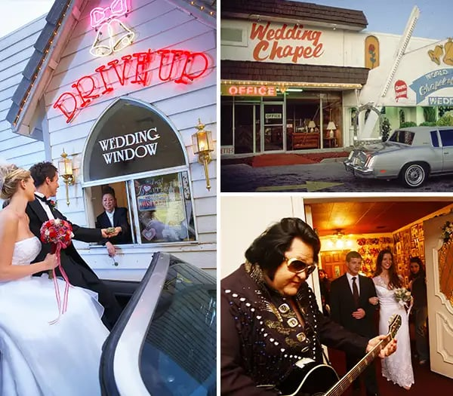

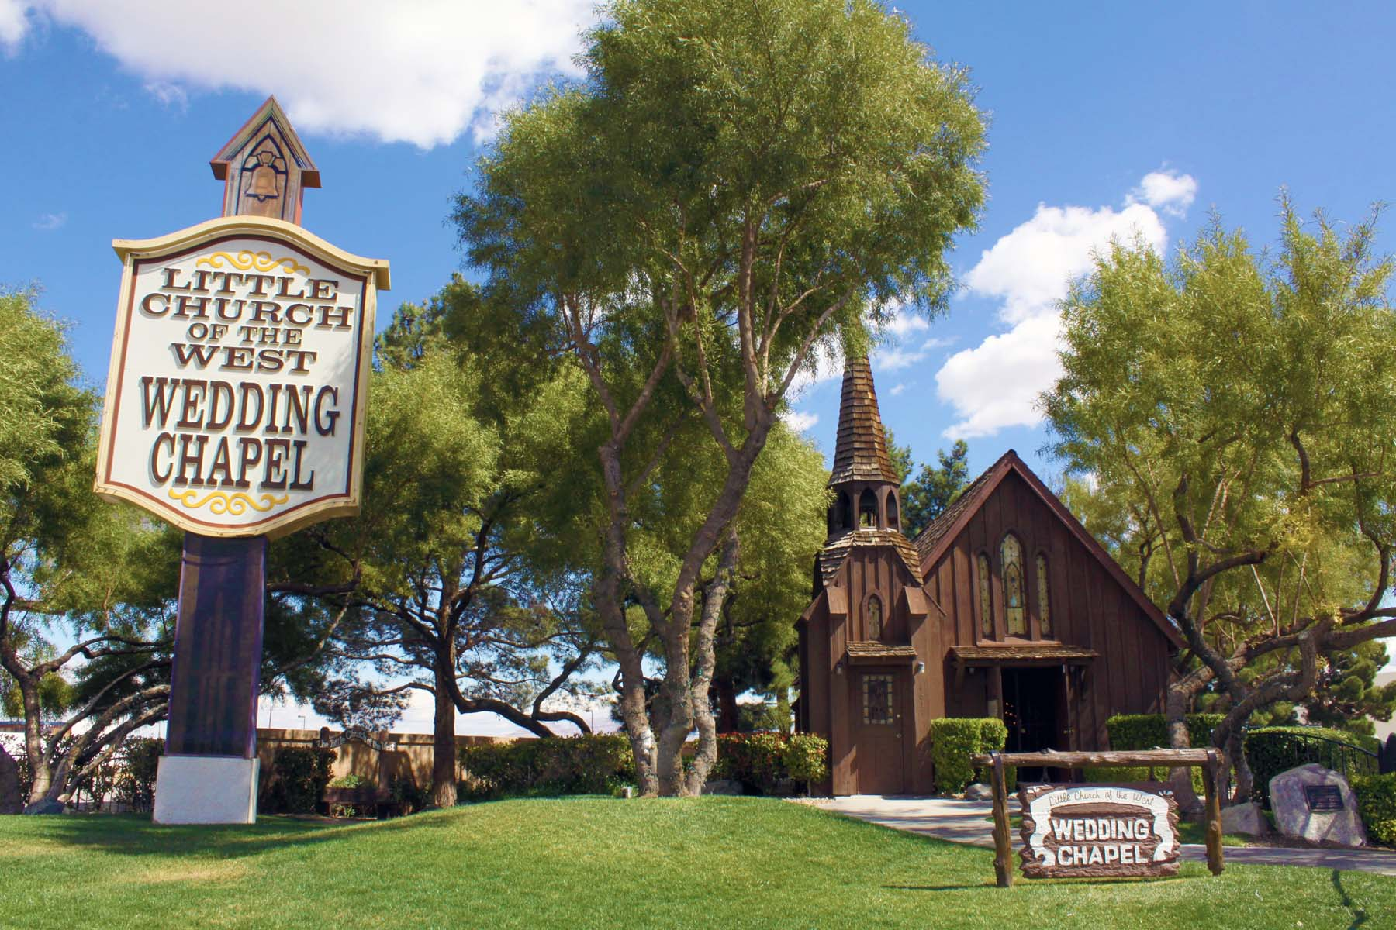

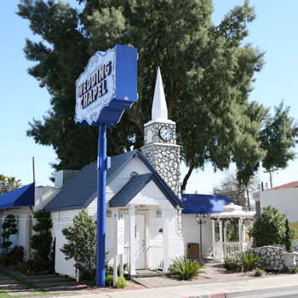

Graceland Wedding Chapel

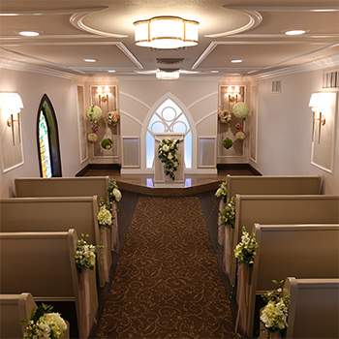

Interior of Graceland Wedding Chapel

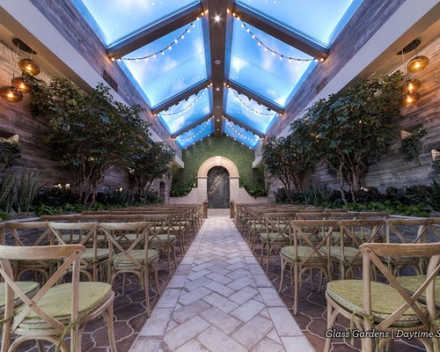

Voted Best Wedding Chapel in Las Vegas 2024