HOW ELVIS BECAME PART OF LAS VEGAS WEDDING CHAPELS HISTORY

There are two events, either one alone or the two together, that describe the role Elvis played in Las Vegas wedding chapels history. The first event involved the filming and subsequent release of the movie, VIVA LAS VEGAS (1964), starring Elvis and Ann-Margaret

When the wedding scene in the film was shot, many tabloid magazines published photos of the "wedding" and suggested that Elvis Presley and Ann-Margret really had gotten married. the Little Church of the West was the location used in the closing scene.

The chemistry between the two stars was apparently genuine during filming. Presley and Ann-Margret began an affair, and this affair received considerable attention from film and music gossip columnists. This public airing of an affair led to a showdown with Presley's worried girlfriend Priscilla Beaulieu.

In her 1985 book, "Elvis and Me", Priscilla Presley described the difficulties that she experienced when the gossip columnists erroneously "announced" that Ann-Margret and Presley had become engaged to be married. In her memoirs, Ann-Margret refers to Elvis Presley as her "soul mate" and stated: "We felt there was a need in 'The Industry' for a female Elvis Presley."

The second event involves the naming of Graceland Wedding Chapel and the first Elvis impersonator wedding in a wedding chapel. Late one evening in 1967, roused by an unexpected knock on the door, Ollie McKee, first owner of the then named Greta Green Wedding Chapel, went to greet his visitors. On the stoop, he came face-to-face with Elvis and his entourage.

According to legend passed down from owner to owner of the Graceland Wedding Chapel, Elvis said "I pass by all the time, and I always wanted to stop in because it reminds me of home." McKee goes on to say that "Presley was in search of a venue to wed the love of his life, a striking beauty with long dark hair, pale blue eyes, and porcelain skin named Priscilla." McKee, a big Elvis fan, gave the musician a tour of the quaint home-turned-wedding venue. The sanctuary was beautiful, Presley admitted, but too small for the party he and his fiancé were planning. Disappointed, McKee asked Elvis how he would feel if he changed the chapel’s name to [Graceland](https://www.atlasobscura.com/places/the-jungle-room-at-graceland-memphis-tennessee). McKee said that "Elvis, ... flashing his million-dollar smile, gave me his blessing." McKee sold the chapel shortly thereafter. Ultimately, Elvis and Priscilla were married in a private suite in the Aladdin Hotel, today the site of the Planet Hollywood hotel.

The next owner of the Graceland Wedding Chapel did not hesitate to cash in on what may or may not have been a legend. "Although performers had been impersonating Elvis since the mid-1950s—the [first known Elvis lookalike](https://books.google.com/books?id=j9UfRzhfQrQC&pg=PA17#v=onepage&q&f=false), Carl “Cheesie” Nelson from Texarkana, AK even performed with the King in 1954—it was the Graceland Wedding Chapel that introduced Elvis impersonators to the wedding game.

That same year, the chapel performed the very first Elvis impersonator wedding in Las Vegas. Today, every chapel has, at the very least, the option to add an Elvis impersonator to a chapel or hotel wedding. There are more than enough Elvis impersonators in Las Vegas to go around.

Every Elvis in the Vegas wedding game is a little different. "Some dress in high-collared white jumpsuits and perform the musician in his paunchy, middle-aged era. Others do a younger, sleeker, more coiffed version of the singer. Some are legitimate musicians with guitar skills...that help to sell the character. Others, not so much." In some cases, Elvis impersonators even officiate at the ceremony.

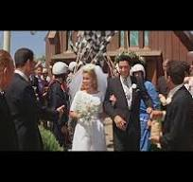

Wedding Scene in Viva Las Vegas

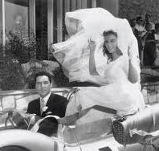

Wedding Scene in VIva Las Vegas

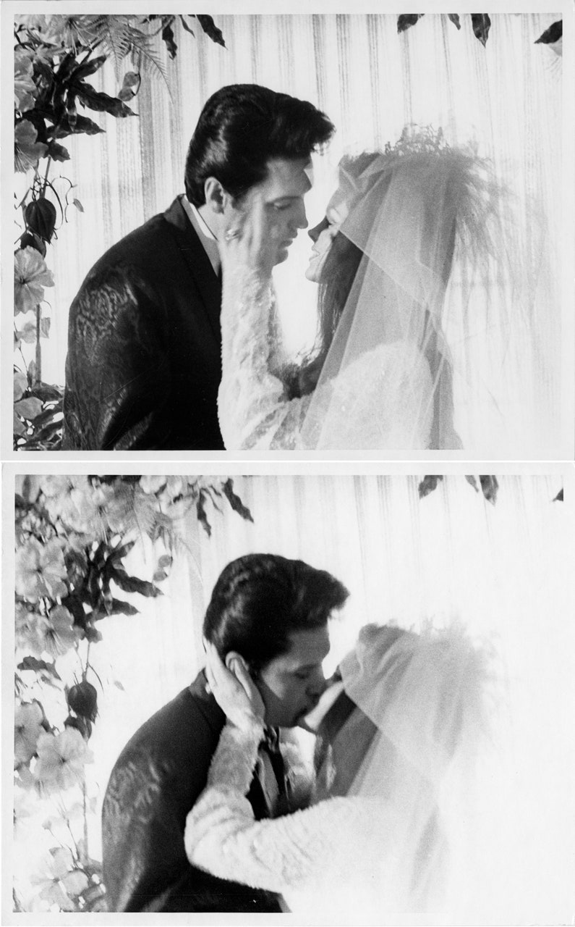

"You may kiss the bride" Elvis and Priscilla's wedding at the Aladdin Hotel

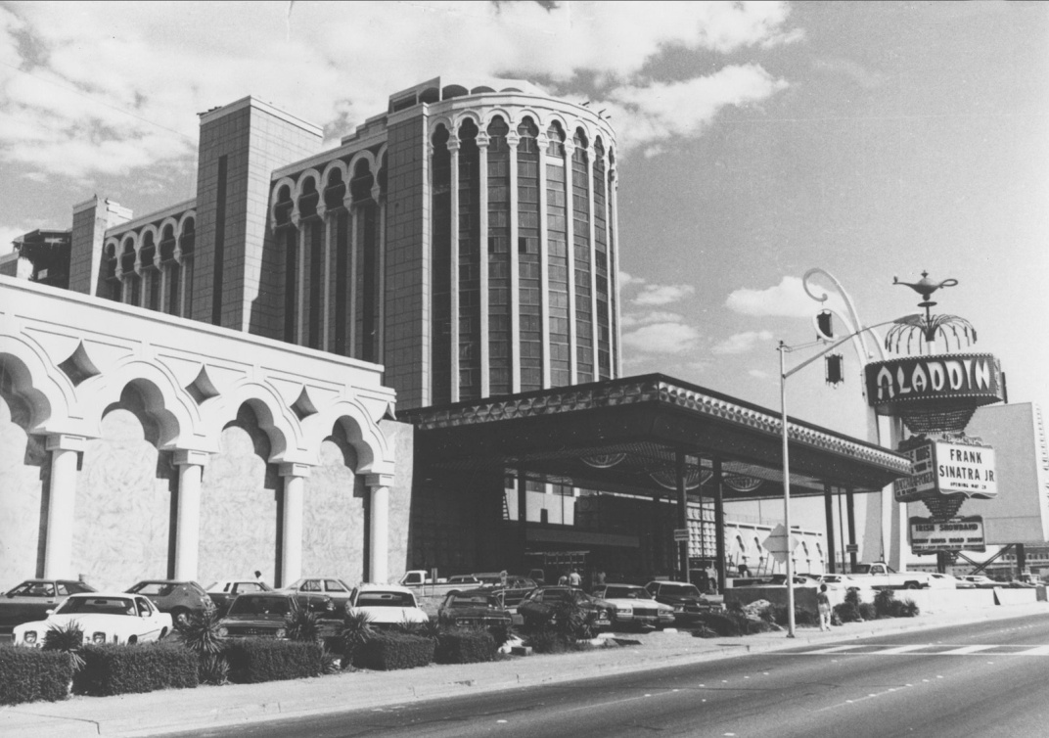

The Aladdin Hotel